The Dutton District Lions Club presents….
2019 Dutton Sports-Fest
Swim Meet

When: July 21st, 2019
Warm ups @ 8:30am
Where: Dutton-Dunwich Community Pool
196 Queen St,
Dutton, Ontario
N0L 1J0
Phone: 519-762-2772
Registration: $10.00 /swimmer (includes $5 event fee & $5 lunch fee)
Sports-Fest Swim Meet

Dear Coaches,

The Dutton Dolphins Swim Team would like to invite you to the 2019 Dutton Sports-Fest Swim Meet, at the Dutton Pool on Sunday July 21st 2019.

Warm ups will begin at 8:30am and the meet will start at 9:00am. Coaches meeting will be at 8:30am where registration fees can be paid.

The age of swimmers will be determined AS OF JULY 1st. swimmers are encouraged to participate in 3 out of 4 strokes plus the I.M. where age group applicable. WINTER SWIMMERS WILL HAVE TO ADD 1 YEAR TO THEIR AGE TO DETERMINE AGE-GROUP PLACEMENT. (an 11 year old would swim as a 12 year old if they are a winter swimmer).

Enclosed in the meet package is the swimmer event list, rules and regulations, and team roster sheets. Please fill out the team rosters completely and email them to aquatics@duttondunwich.on.ca by Wednesday July 17th. No late registrations will be accepted.

We look forward to your participation in the Dutton Sports-Fest Swim Meet!!!!

Dutton Dolphins 2019 meet – RULES AND REGULATIONS
- Strokes and turns must follow Swim Canada regulations. Strokes and turns decision is final. Discrepancies should be brought to the attention of the strokes and turns immediately by a coach only.

- Any swimmer who has been competing or training with a swim club at any time between June 1st, 2017 and June 1st, 2019 shall have one year added to their age. High School swim teams as recognized by OFSAA will not be considered “club” and shall swim in their age category.

- College and University students, lifeguards, instructors and coaches will not be allowed to compete.

- Age is to be determined as of July 1st, 2019. Swimmers must swim in the same age category for all individual races for the entire meet.

- Swimmers will be allowed to swim 3 strokes and I.M.

- Two-hand touches are required for Butterfly and Breaststroke for U10 and up, U8 will be at the discretion of the stroke judge.

- Swimmers will be allowed 1 false start. The second will result in disqualification.

- 8 & under competitors will be disqualified for:
  - wrong stroke to gain advantage
  - standing on the bottom of the pool or grabbing lane ropes or sides to gain advantage
  - interfering with another swimmer

- 9 & over competitors will be disqualified for:
  - wrong stroke
  - touching bottom of pool, ropes or sides to gain advantage
  - not doing a 2-hand touch in butterfly and breaststroke

- No flotation devices are allowed to assist swimmers.

- Points will be awarded as follows:
  - 1st – 7pts,
  - 2nd – 5pts,
  - 3rd – 4pts,
  - 4th – 3pts,
  - 5th – 2pts,
  - 6th – 1pts

- Gold, silver and bronze medals will be awarded for each individual age group. Ribbons will be awarded for 1st through 6th place.

- A trophy will be awarded to the top team with the most points.

- Have fun and swim your best, support your team and please respect the pool.

EVENT SCRIPT
Warm ups: @ 8:30am
Coaches Meeting: @ 8:30am
Meet Begins @ 9:00am
Lunch Time: Will be announced
Medal Ceremony: After Freestyle

INDIVIDUAL MEDLEY
U8 Girls/Boys 50m Individual Medley (Two Strokes)
U10 Girls/Boys 100m Individual Medley (Fly, Back, Breast, Free)
U12 Girls/Boys 100m Individual Medley (Fly, Back, Breast, Free)
U14 Girls/Boys 100m Individual Medley (Fly, Back, Breast, Free)
15+ Girls/Boys 100m Individual Medley (Fly, Back, Breast, Free)

BUTTERFLY
U6 Girls/Boys 25m Butterfly
U8 Girls/Boys 25m Butterfly
U10 Girls/Boys 25m Butterfly
U12 Girls/Boys 50m Butterfly
U14 Girls/Boys 50m Butterfly
15+ Girls/Boys 50m Butterfly

BACKSTROKE
U6 Girls/Boys 25m Backstroke
U8 Girls/Boys 25m Backstroke
U10 Girls/Boys 25m Backstroke
U12 Girls/Boys 50m Backstroke
U14 Girls/Boys 50m Backstroke
15+ Girls/Boys 50m Backstroke

BREASTSTROKE
U6 Girls/Boys 25m Breaststroke
U8 Girls/Boys 25m Breaststroke
U10 Girls/Boys 25m Breaststroke
U12 Girls/Boys 50m Breaststroke
U14 Girls/Boys 50m Breaststroke
15+ Girls/Boys 50m Breaststroke

FREESTYLE
U6 Girls/Boys 25m Freestyle
U8 Girls/Boys 25m Freestyle
U10 Girls/Boys 25m Freestyle
U12 Girls/Boys 50m Freestyle
U14 Girls/Boys 50m Freestyle
15+ Girls/Boys 50m Freestyle

Registering your team:
Please fill in completely; maximum 3 events plus IM (except U6 no IM) – (please check last column if swimmer has swam with a club anytime between September 1, 2018 and June 1, 2019).
Or submit via email to: Ryan Fink (Aquatics Supervisor)
aquatics@duttondunwich.on.ca
Registration Due By: July 17, 2019
*Note: Please submit registration by the due date stated above. No late registrations will be excepted. There will be absolutely no refunds for registered swimmers after July 17th, 2019 or the day of the meet. Teams must pay for the number of registered swimmers including day of entries.

Please complete the pre-marshalling sheet attached and send via email by July 17th, 2019. Thank you.

Any questions or concerns, please contact us at:

Phone: 519-762-2772
Email: aquatics@duttondunwich.on.ca
For more information on our meet visit us at:
Facebook: Dutton Dolphins Swim Team or Dutton Dunwich Community Pool
For directions:
Please see the attached map on last page of package

Thank You,
Dutton Pool Aquatic Staff
Team Name: __________________________________________

Name | Age as of July 1st, 2018 | Male/  Female | Fly | Back | Breast | Free | IM | Club
Map to the Dutton Dunwich Community Pool
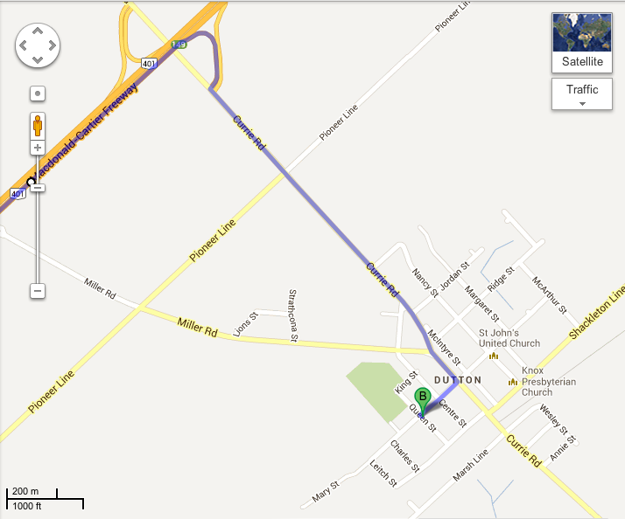
196 Queen Street, Dutton, Ontario, N0L 1J0
Parking for swim meet will be at the Dutton-Dunwich Community centre

Parking for swim meet will be at the Dutton-Dunwich Community centre

